**Scripting schema and table data in Sql Server Management Studio**

**Single table with schema and data**

1. In Sql Server Management Studio(SSMS), right click the database containing the tables to export and choose **Tasks>Generate Scripts…**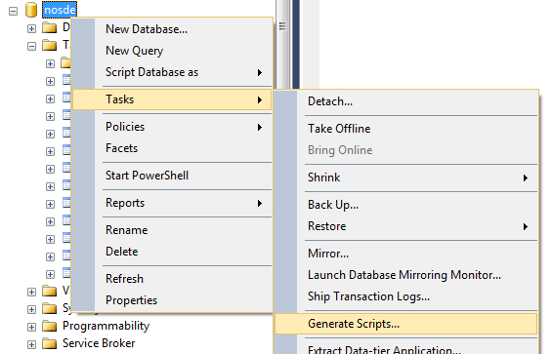
2. In the Generate and Publish Scripts dialog, click **Next** to move past the introduction, choose Select Specific Database Objects.  
   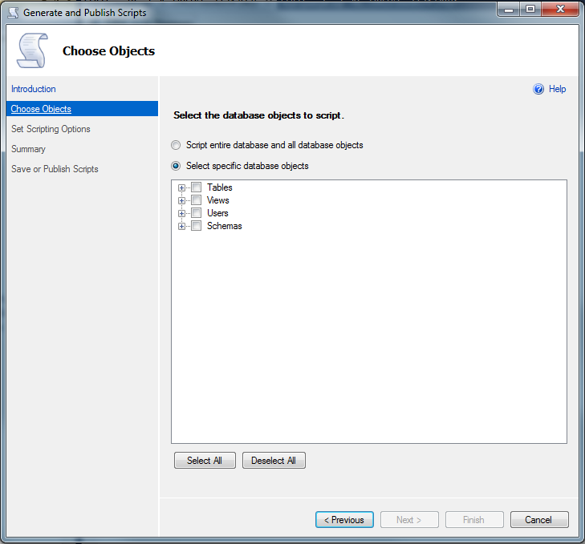
3. Expand **Tables** and select the desired table to export. Click **Next**.  
   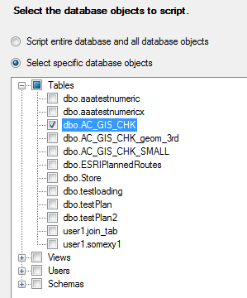
4. In the **Set Scripting Options** dialog, choose **Save to File** if not already selected. Choose a location to save a .sql file or choose the **Clipboard** or **Query window** option. then click the **Advanced** button.  
   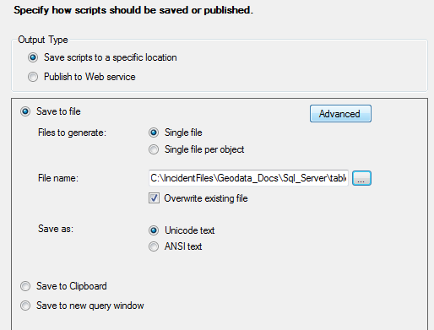
5. Clicking the Advanced button allows for option to include insert statements for each record. In the **Options** dialog, under **Types of data to script,** choose **Schema and data.** Click **OK**.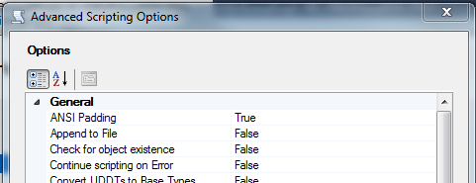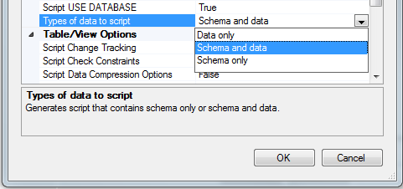
6. Click **Next** to see a summary of the requested export.  
   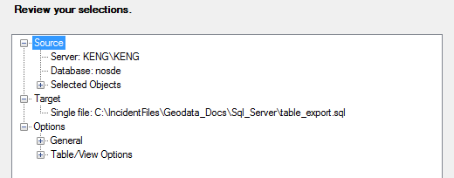
7. Click **Next** to validate and save the script.  
     
   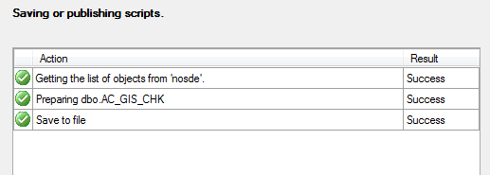
8. Click **Finish.**
9. A new script has been generated.  
   